Grönwall’s inequality

$$\left[alias\right]$$

**Grönwall–Bellman inequality**

**Grönwall's lemma**



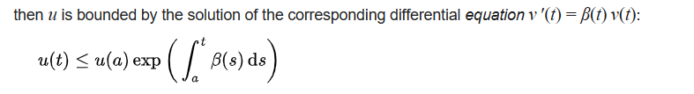

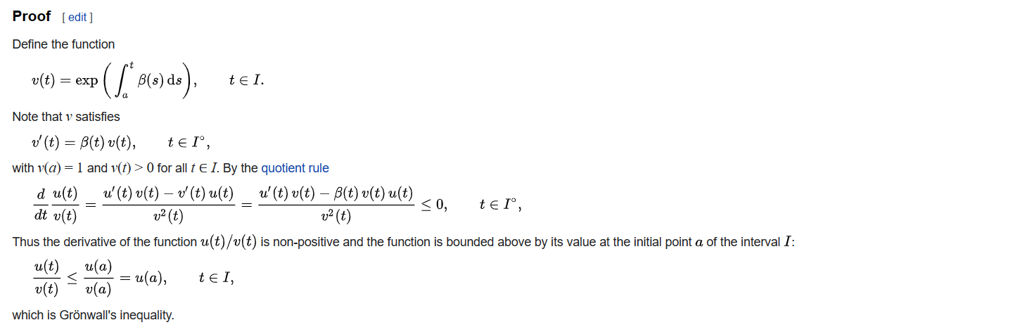

Ref:

[Grönwall's inequality - Wikipedia](https://en.wikipedia.org/wiki/Gr%C3%B6nwall%27s_inequality)

[Gronwall inequality - YouTube](https://www.youtube.com/watch?v=vP3Bd_c_EEw)